PROJECT REPORT
Script-Controlled ACL – Restrict Record Access Based on Field Value

Platform: ServiceNow
Team ID: SWTID-2026-6519
Team Size: 5
Date: 04 October 2026

Role | Name
Team Leader | SUHAS V
Team Member | SURESHBABU M
Team Member | VIGNESH KUMAR S
Team Member | ANUJA P
Team Member | ARCHANA S

1. Introduction

1.1 Project Overview
This project demonstrates how to implement a script-controlled Access Control List (ACL) in ServiceNow to restrict users from viewing records unless they meet specific conditions. Only users belonging to the EEE branch (role bb1) can view records of the custom table Institution Details (u_institution_details) where the Branch field is set to EEE, while administrators retain full access. Separate ACLs control creating (bb2), editing (bb3) and deleting (bb4) records.

1.2 Purpose
- Protect sensitive student data from unauthorised viewing, modification, creation and deletion.
- Show how user roles and record field values are evaluated together to make access decisions.
- Provide a reusable pattern for record-level security in lists, forms and the Service Portal.

2. Ideation Phase

2.1 Problem Statement
PS | I am | I'm trying to | But | Because | Which makes me feel
PS-1 | a ServiceNow admin (owner of student records) | ensure that only users of the EEE branch can see EEE records | every user who can open the table can see records of all branches | table access is not filtered by the Branch field by default | worried and exposed – student data could leak
PS-2 | an EEE branch user | view, create, edit and delete only the records I am permitted to | access is not separated per operation and per role | the same role gives read, write and delete together | frustrated and unsure what I am allowed to do

2.2 Empathy Map Canvas
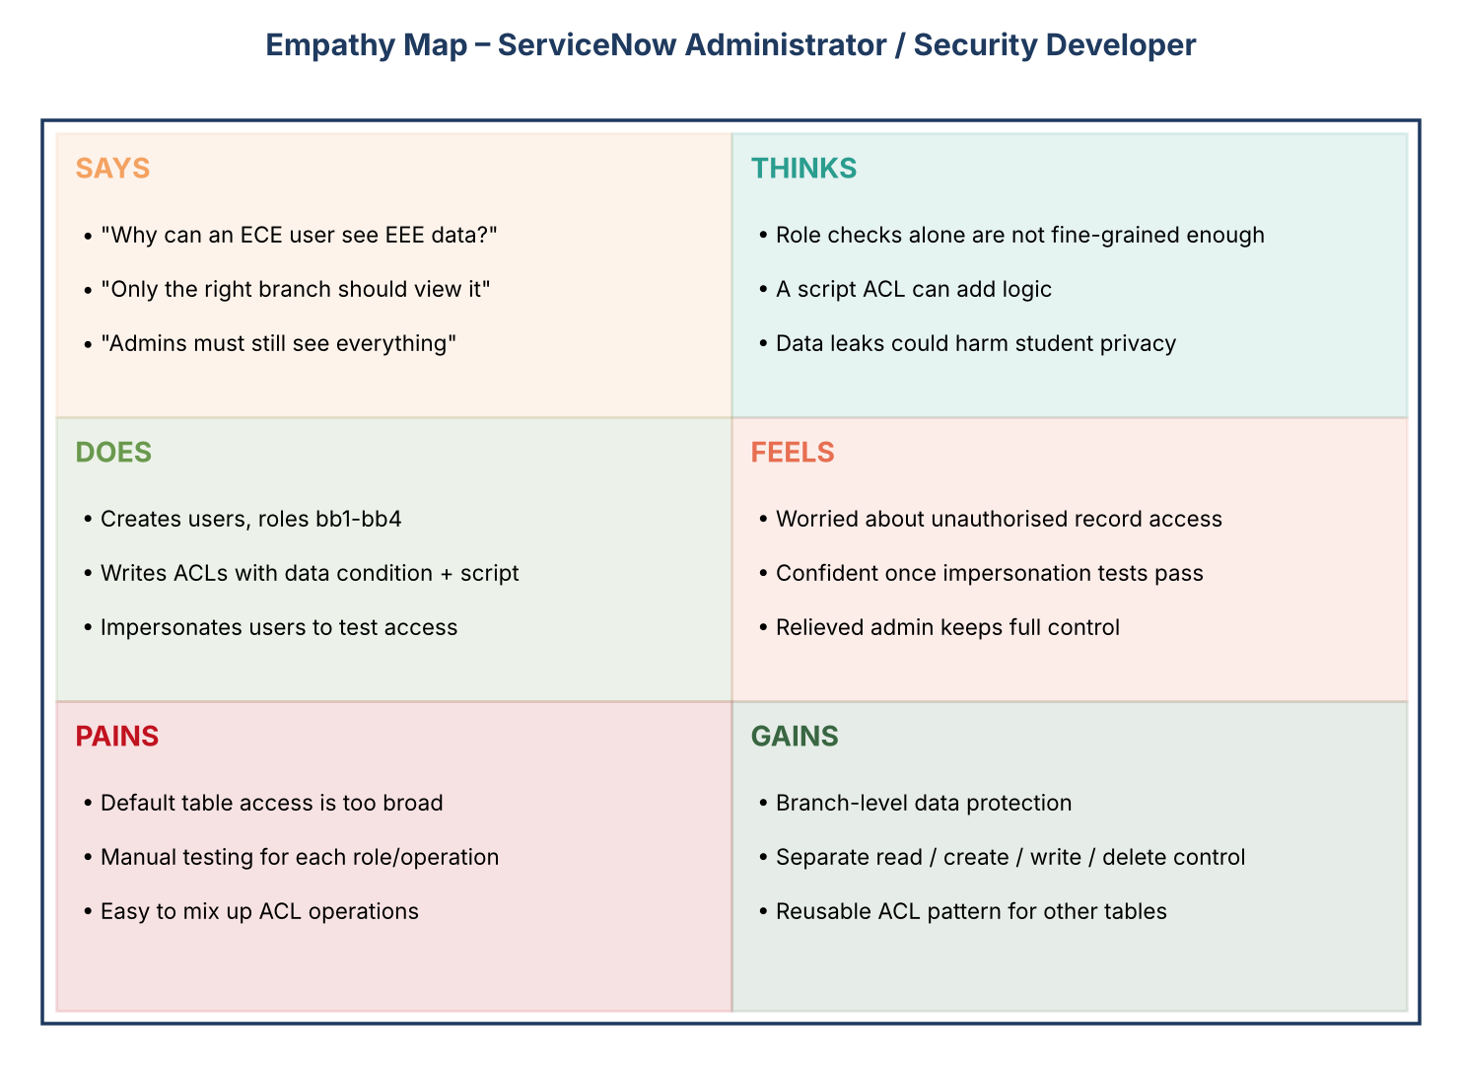

2.3 Brainstorming
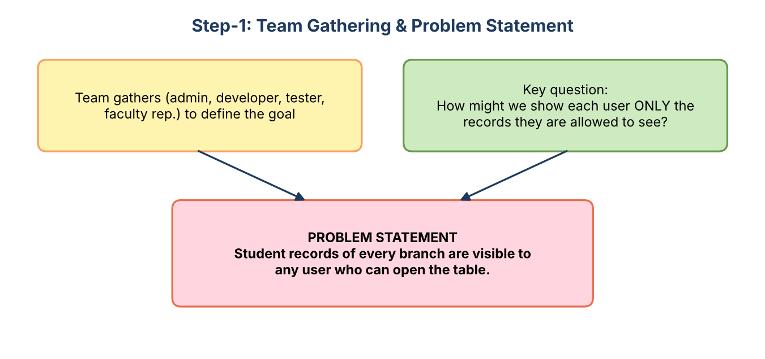
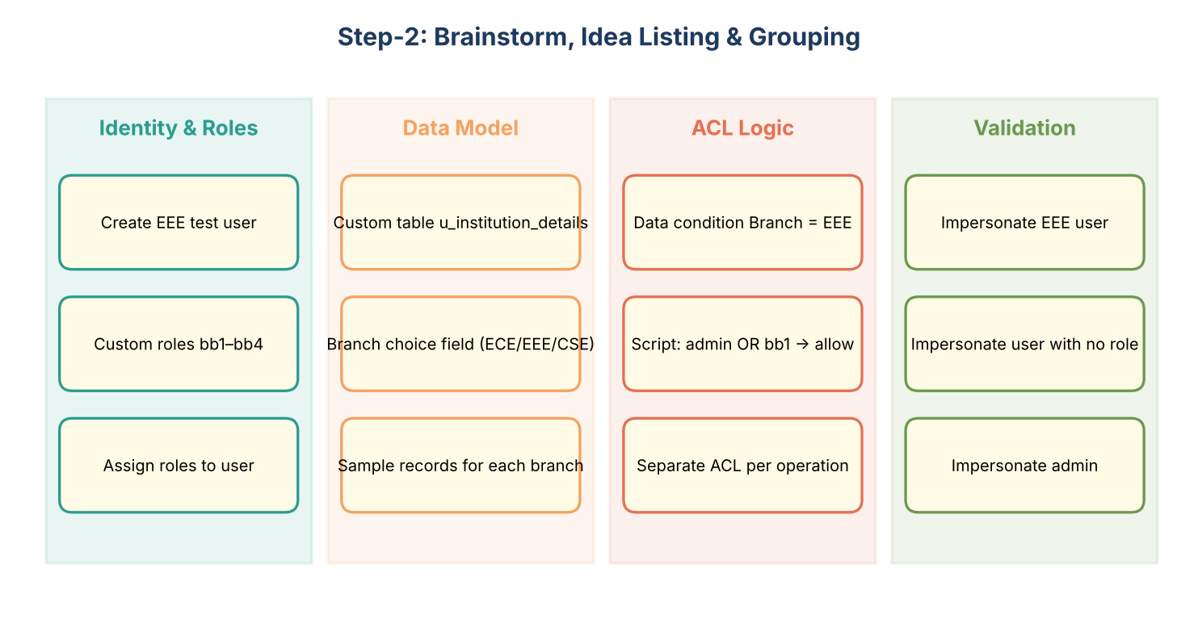
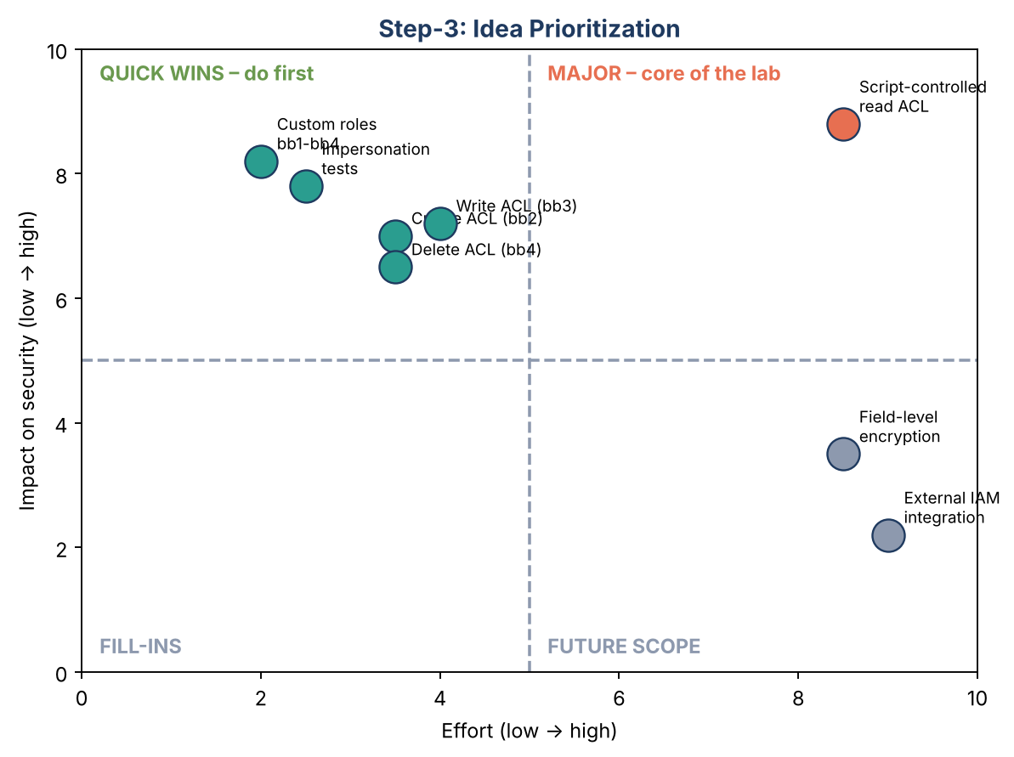

3. Requirement Analysis

3.1 Customer Journey Map
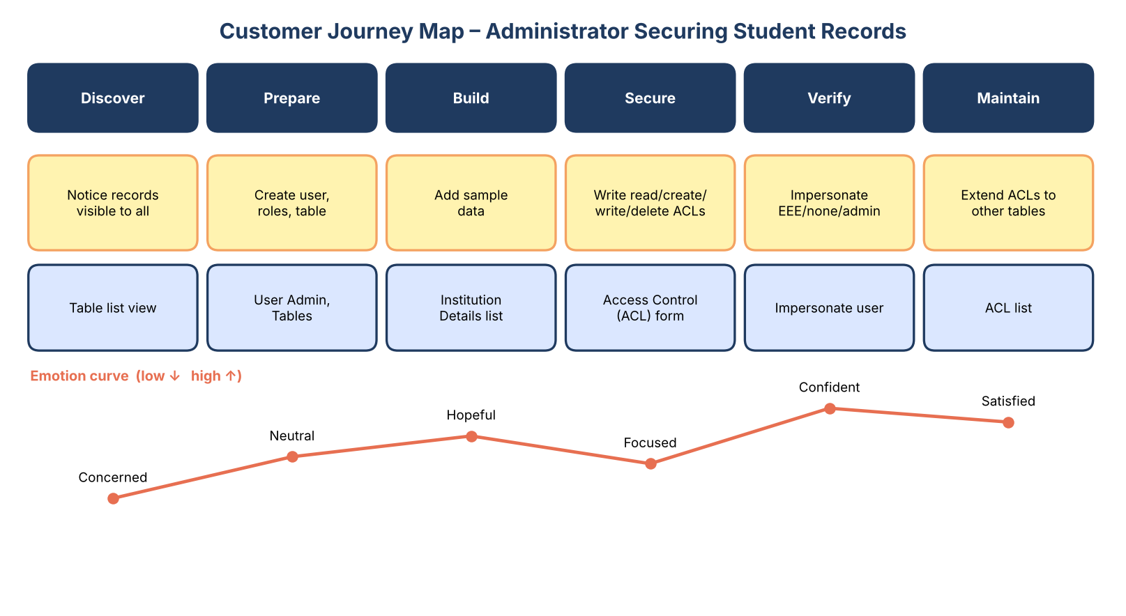

3.2 Solution Requirement

Functional requirements
FR No. | Functional Requirement (Epic) | Sub Requirement
FR-1 | User & Role Management | Create test user EEE User  Create custom roles bb1, bb2, bb3, bb4  Assign all roles to the EEE User
FR-2 | Data Management | Create custom table u_institution_details  Add fields: Roll Number, Student, Faculty, Branch, Email, Phone, Description  Insert sample records for ECE, EEE and CSE
FR-3 | Read ACL (script-controlled) | Require role bb1  Data condition: Branch is EEE  Advanced script: admin / bb1 → true, others → false
FR-4 | Create ACL | Require role bb2 to see the New button and create records
FR-5 | Write ACL | Require role bb3 to edit records (inline / form)
FR-6 | Delete ACL | Require role bb4 to delete records
FR-7 | Admin Override & Verification | Administrator keeps full access to all branches  Verify through user impersonation (EEE User, no-role user, admin)

Non-functional requirements
NFR No. | Non-Functional Requirement | Description
NFR-1 | Usability | Access rules are applied transparently; users simply see the lists/forms they are allowed to see (e.g. New button appears only with bb2).
NFR-2 | Security | Least privilege: separate role per operation (read, create, write, delete); EEE branch data hidden from other users; changes to ACLs need security_admin elevation.
NFR-3 | Reliability | ACLs are evaluated by the platform on every request, so rules cannot be bypassed from list, form or Service Portal.
NFR-4 | Performance | Simple role checks and one field condition – negligible overhead; no GlideRecord queries inside the script.
NFR-5 | Availability | Runs on the ServiceNow cloud instance; ACLs are active as soon as saved (and can be captured in an update set).
NFR-6 | Scalability | Same pattern can be copied to other tables/branches by changing the table, role and data condition.

3.3 Data Flow Diagram
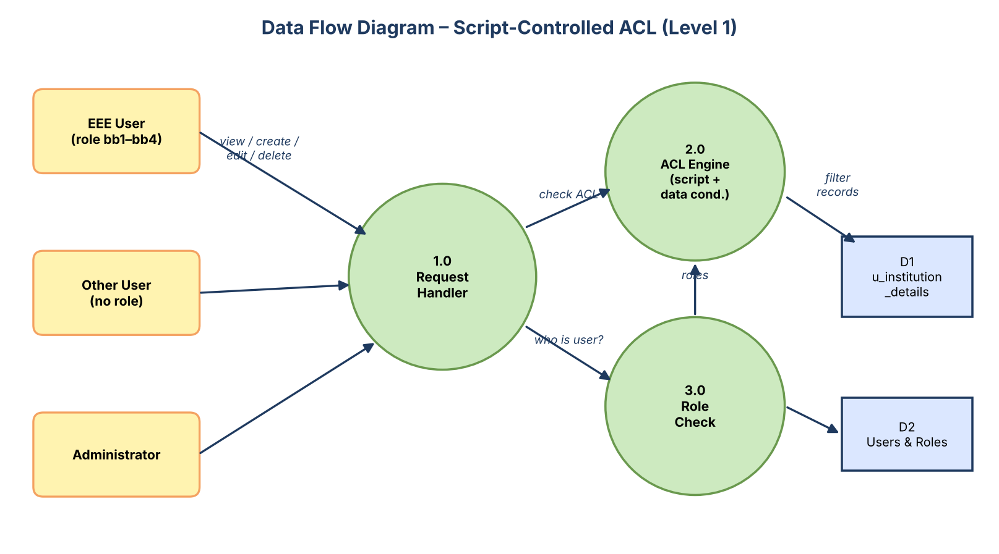

3.4 Technology Stack
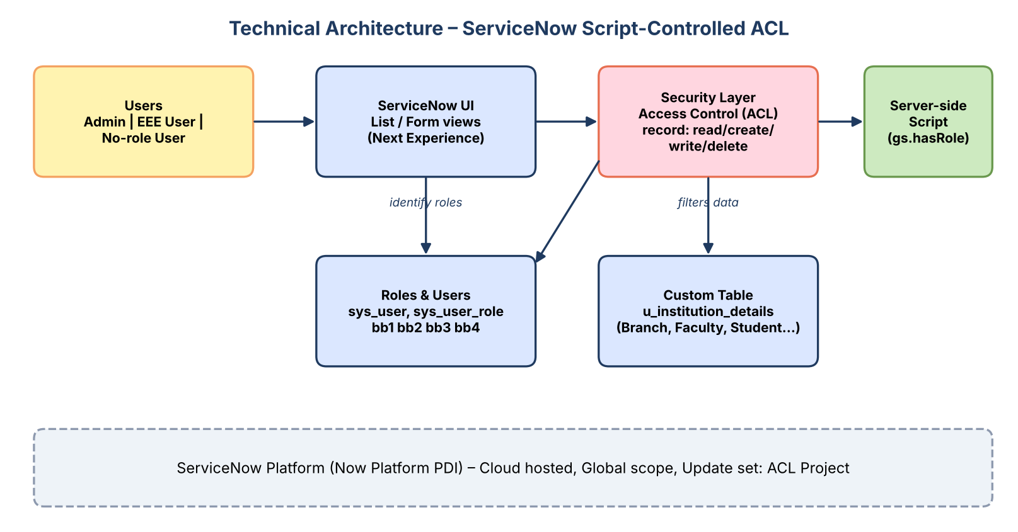
- User interface: ServiceNow Next Experience (list / form / Service Portal)
- Logic: Access Control (ACL) records with data condition and server-side JavaScript (gs.hasRole)
- Data: custom table u_institution_details on the ServiceNow cloud database
- Infrastructure: ServiceNow Personal Developer Instance (Global scope, update set 'ACL Project')

4. Project Design

4.1 Problem Solution Fit
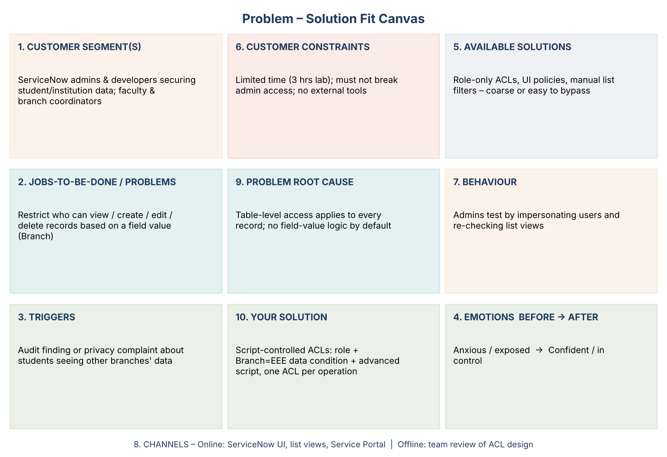

4.2 Proposed Solution
S.No. | Parameter | Description
1 | Problem Statement (Problem to be solved) | Records in a shared table (Institution Details) are visible to every user who can open it. Students/staff of one branch should not see – or change – another branch's data, while admins still need full access.
2 | Idea / Solution description | Implement script-controlled Access Control Lists (ACLs) on u_institution_details: a Read ACL (role bb1 + data condition Branch is EEE + advanced script), and separate Create (bb2), Write (bb3) and Delete (bb4) ACLs. Validate with impersonation.
3 | Novelty / Uniqueness | Combines three layers in one rule – role, field-value data condition and server-side script – and gives each operation its own role, producing fine-grained, record-level security without custom code in the UI.
4 | Social Impact / Customer Satisfaction | Protects personal data (names, emails, phone numbers) of students; builds trust with students, faculty and administrators and supports privacy compliance.
5 | Business Model (Revenue Model) | Reusable security pattern/accelerator for ServiceNow implementation partners and training labs; can be offered as part of a security hardening service or a lab/training module.
6 | Scalability of the Solution | Highly scalable: add branches by changing the data condition, add tables by copying the ACLs, and manage access through roles/groups instead of individual users.

4.3 Solution Architecture
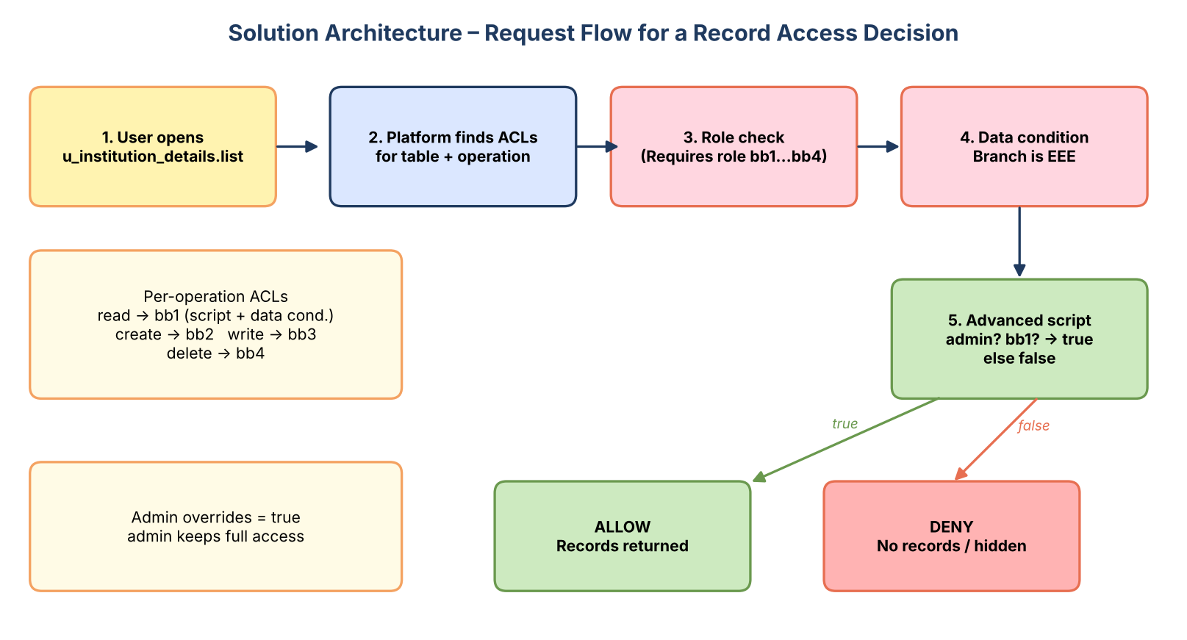

5. Project Planning & Scheduling

5.1 Project Planning
Sprint | Epic | USN | User Story / Task | Pts | Priority
Sprint-1 | User & Role Management | USN-1 | As an administrator, I can create a test user (EEE User) so that I can test branch-based access. | 1 | High
Sprint-1 |  | USN-2 | As an administrator, I can create the custom roles bb1, bb2, bb3 and bb4. | 2 | High
Sprint-1 |  | USN-3 | As an administrator, I can assign all four roles to the EEE User. | 1 | High
Sprint-1 | Data Model | USN-4 | As an administrator, I can create the custom table Institution Details (u_institution_details). | 2 | High
Sprint-1 |  | USN-5 | As an administrator, I can add the fields Student Roll Number, Student Name, Faculty Name, Branch, Email, Phone Number and Description. | 3 | High
Sprint-1 |  | USN-6 | As an administrator, I can insert sample records for ECE, EEE and CSE branches. | 2 | Medium
Sprint-2 | Read ACL | USN-7 | As an administrator, I can elevate to security_admin and create a Read ACL (record, read, advanced) on u_institution_details that requires role bb1. | 3 | High
Sprint-2 |  | USN-8 | As an administrator, I can add the data condition Branch is EEE to the Read ACL. | 2 | High
Sprint-2 |  | USN-9 | As an administrator, I can add an advanced script that returns true for admin / bb1 and false for everyone else. | 5 | High
Sprint-2 |  | USN-10 | As a user with role bb1, I can open the Institution Details list and see only EEE-branch records. | 3 | High
Sprint-3 | Create & Write ACL | USN-11 | As an administrator, I can create a Create ACL that requires role bb2. | 3 | High
Sprint-3 |  | USN-12 | As a user with bb1 and bb2, I can see the New button and create records. | 2 | High
Sprint-3 |  | USN-13 | As an administrator, I can create a Write ACL that requires role bb3. | 3 | High
Sprint-3 |  | USN-14 | As a user with bb1, bb2 and bb3, I can edit the Description of EEE records inline. | 2 | Medium
Sprint-4 | Delete ACL & Validation | USN-15 | As an administrator, I can create a Delete ACL that requires role bb4. | 3 | High
Sprint-4 |  | USN-16 | As a user with all four roles, I can delete an EEE record. | 2 | High
Sprint-4 |  | USN-17 | As a user without the roles, I must not see any record in the list. | 2 | High
Sprint-4 |  | USN-18 | As an administrator, I can still see the records of all branches. | 2 | High
Sprint-4 |  | USN-19 | As an administrator, I can document the work as a project report. | 3 | Medium

Sprint | Total Story Points | Duration | Start | End (Planned) | Completed
Sprint-1 | 11 | 6 Days | 07 Sep 2026 | 12 Sep 2026 | 11
Sprint-2 | 13 | 6 Days | 14 Sep 2026 | 19 Sep 2026 | 13
Sprint-3 | 10 | 6 Days | 21 Sep 2026 | 26 Sep 2026 | 10
Sprint-4 | 12 | 6 Days | 28 Sep 2026 | 03 Oct 2026 | 12
Velocity = 46 / 4 = 11.5 story points per sprint.
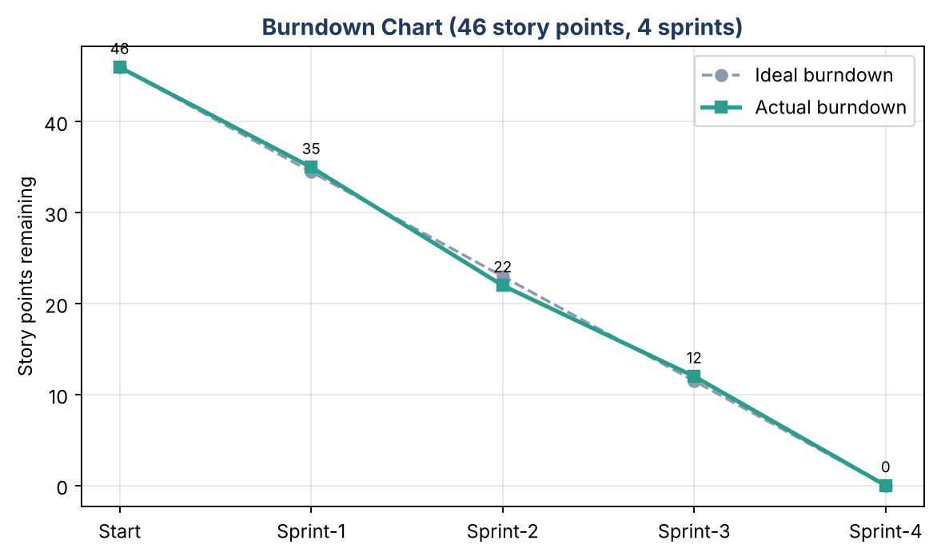

6. Functional and Performance Testing

6.1 Performance Testing
Nine test cases were executed by impersonating the administrator, a user without roles and the EEE user with progressively more roles. All passed (9/9, 100%). List views loaded normally with all four ACLs active; the ACL script uses only role checks, so no measurable overhead was observed.
ID | Scenario | Expected Result | Actual Result | Status
TC-001 | Create test user EEE User | User record is created and active | User EEEUser created and active | Pass
TC-002 | Create roles bb1–bb4 and assign to EEE User | Four roles exist and are assigned | Roles created and assigned | Pass
TC-003 | Create table u_institution_details with fields and 6 sample records | Table, fields and records are saved | Table with 7 fields and 6 records created | Pass
TC-004 | Admin opens Institution Details list | All 6 records (ECE, EEE, CSE) visible | All 6 records visible | Pass
TC-005 | User without roles opens list (negative) | No records are displayed | "No records to display" shown | Pass
TC-006 | User with bb1 opens list (Read ACL) | Only EEE-branch records shown | Only INS0001007 and INS0001004 (EEE) shown | Pass
TC-007 | User with bb1+bb2 checks New button (Create ACL) | New button is available | New button visible; only EEE records shown | Pass
TC-008 | User with bb1+bb2+bb3 edits Description (Write ACL) | Description is edited and saved | Description saved on EEE records | Pass
TC-009 | User with bb1–bb4 deletes a record (Delete ACL) | Selected EEE record is deleted | Delete confirmation shown and record removed | Pass

Observations logged during UAT
ID | Observation | Severity | Status
BG-001 | Branch field is created as type String while the lab asks for Choice (ECE, EEE, CSE). | Low | Closed
BG-002 | Student Roll Number is a String with default getNextObjNumberPadded(), not the Auto Number type. | Low | Closed
BG-003 | Script comment says 'only EEE branch users' but the script checks role bb1; the Branch filter comes from the data condition. | Low | Closed
BG-004 | Script in the lab text has an admin check; screenshot script does not. | Low | Closed
BG-005 | User ID is written as 'EEE User' in text but 'EEEUser' in the screenshot. | Low | Closed

7. Results

7.1 Output Screenshots
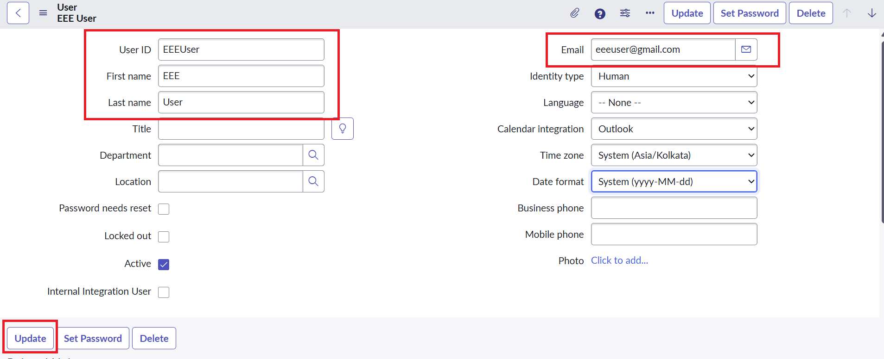
Figure: User EEEUser created
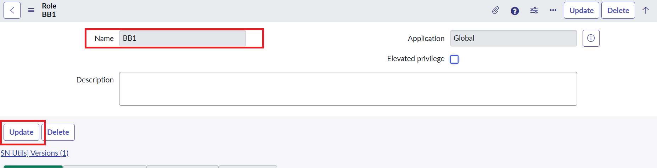
Figure: Role bb1 created (bb2–bb4 created the same way)
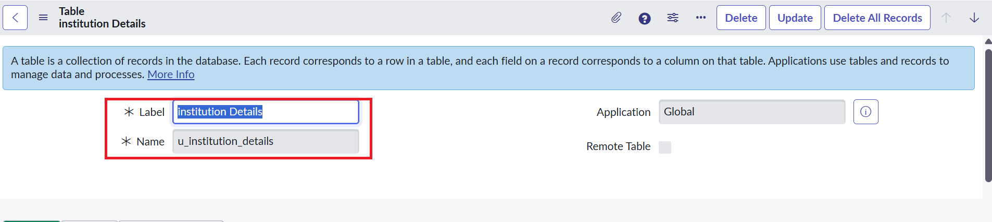
Figure: Custom table Institution Details (u_institution_details)
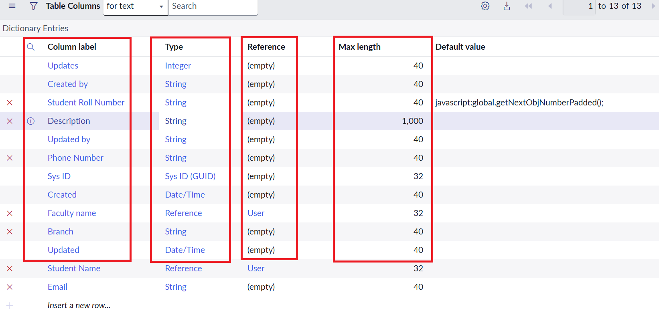
Figure: Table columns / fields
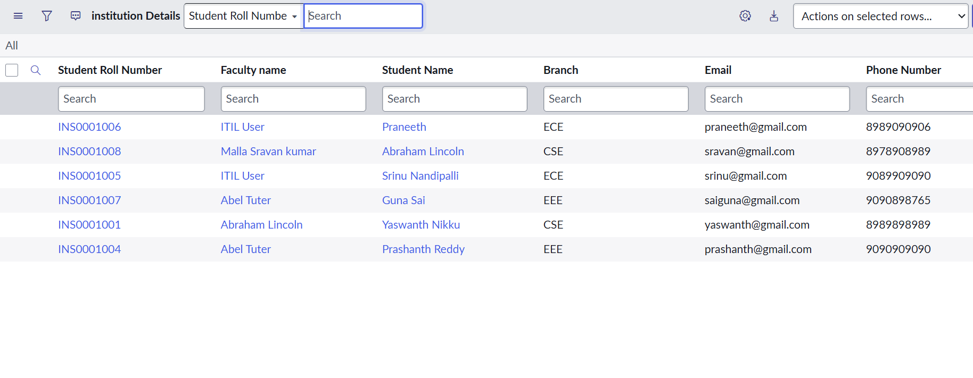
Figure: Sample records for ECE, EEE and CSE
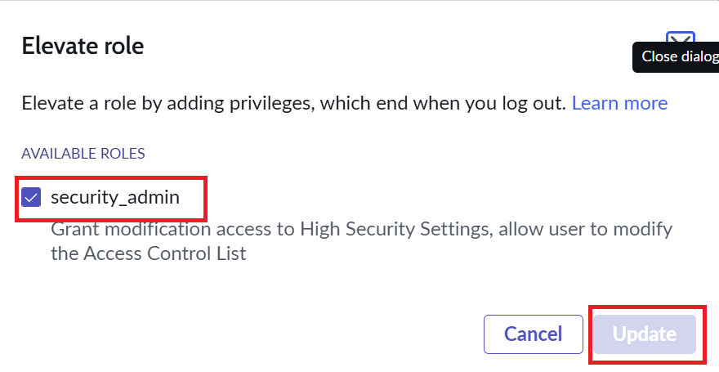
Figure: Elevating the security_admin role
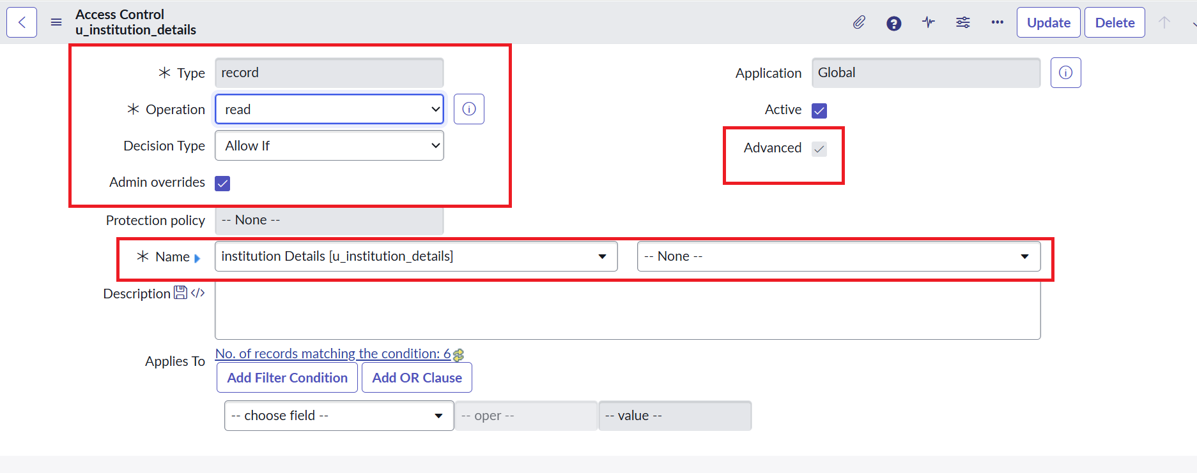
Figure: Read ACL – type, operation, advanced
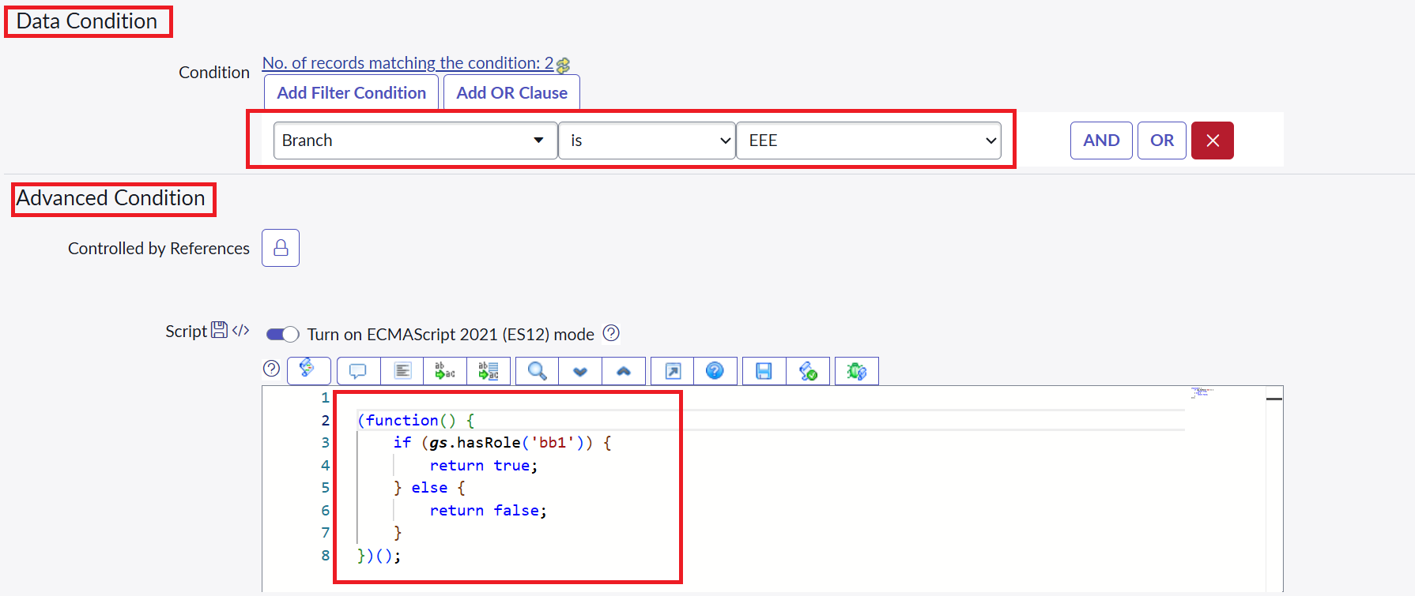
Figure: Read ACL – data condition Branch is EEE and script
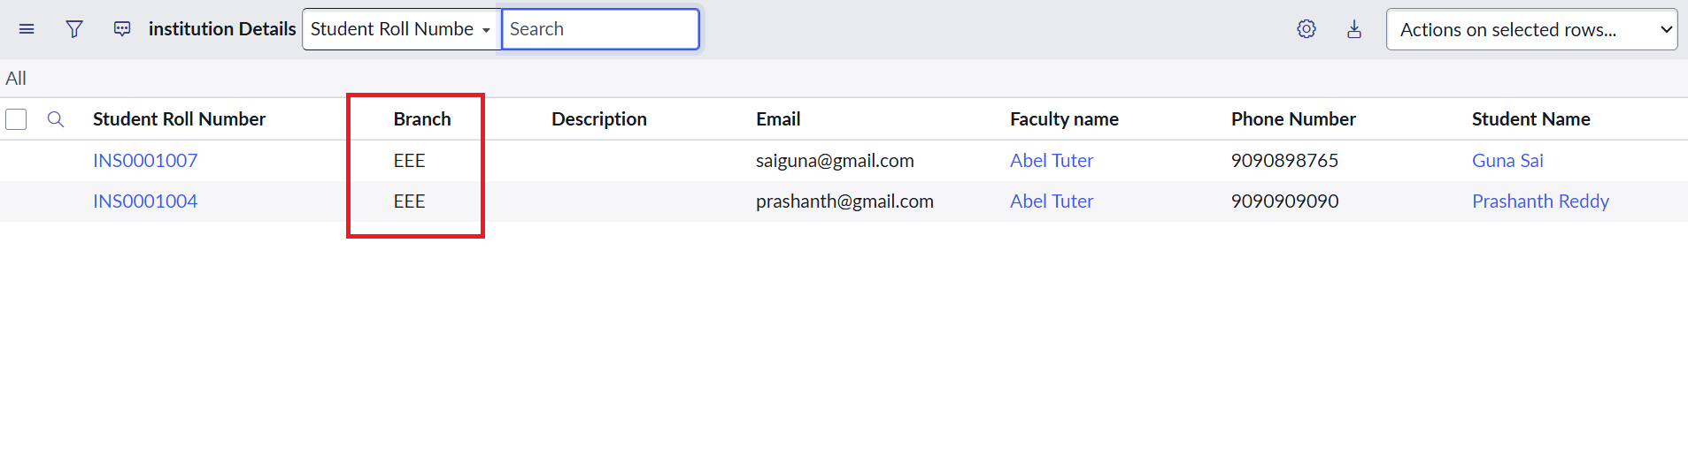
Figure: bb1 user sees only EEE records
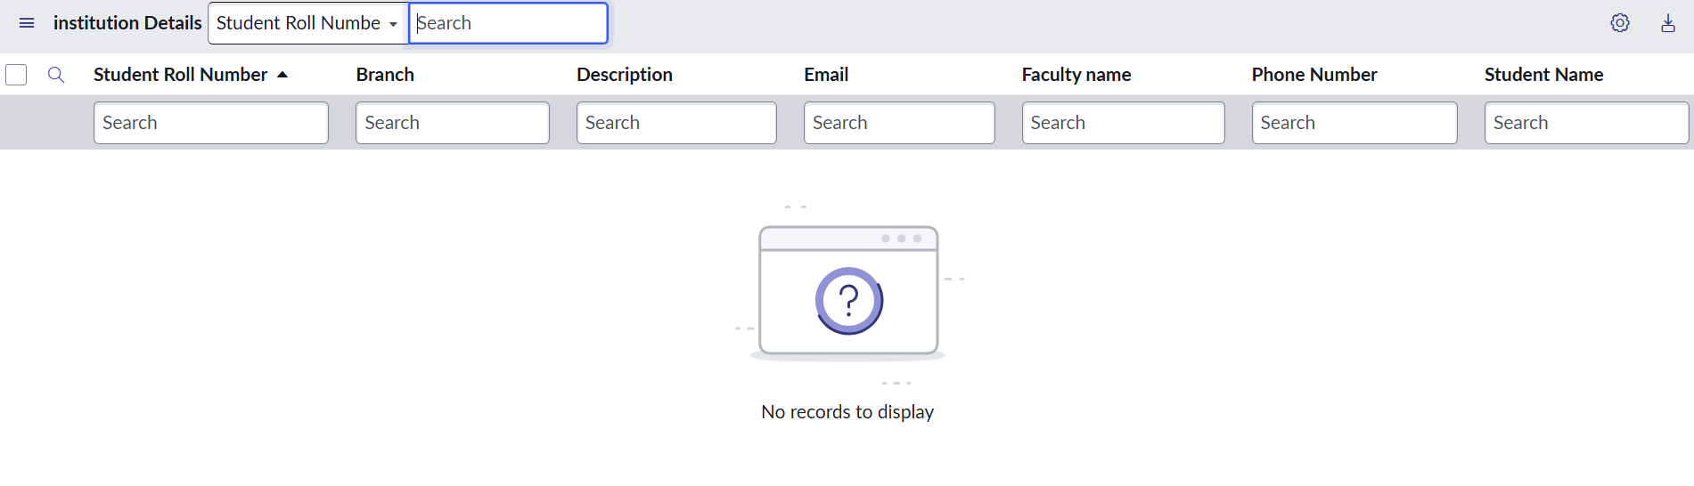
Figure: User without role sees no records
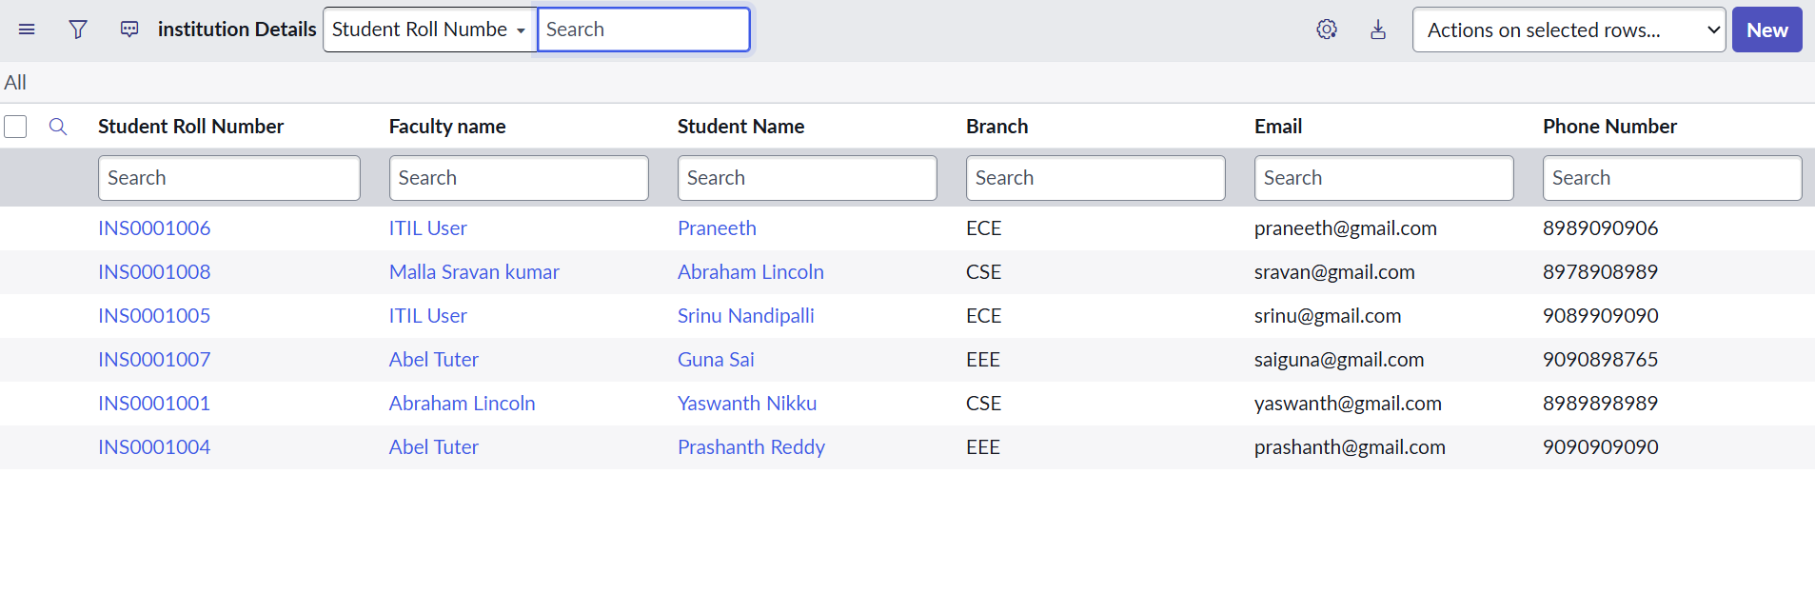
Figure: Admin sees all records
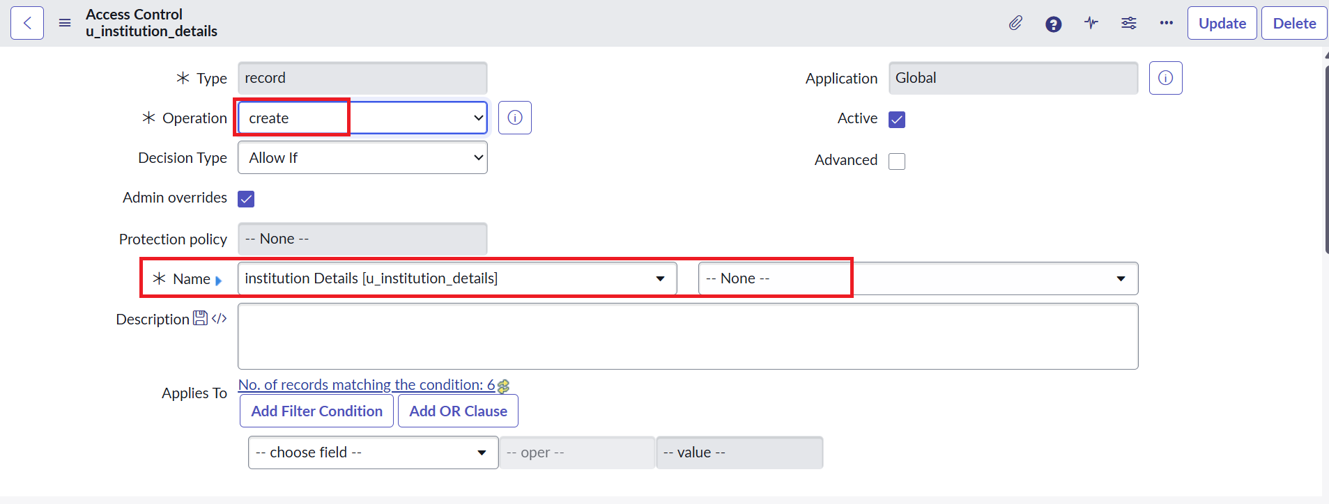
Figure: Create ACL
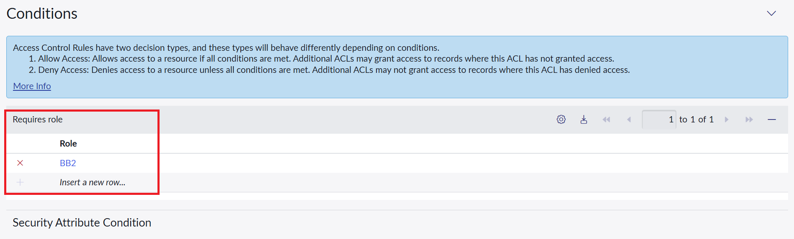
Figure: Create ACL – role bb2
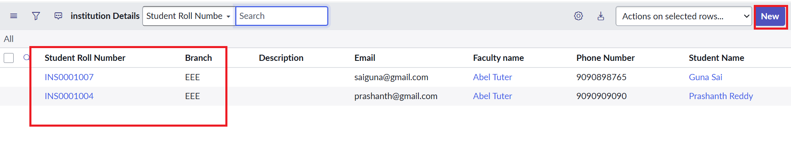
Figure: bb1 + bb2: New button available
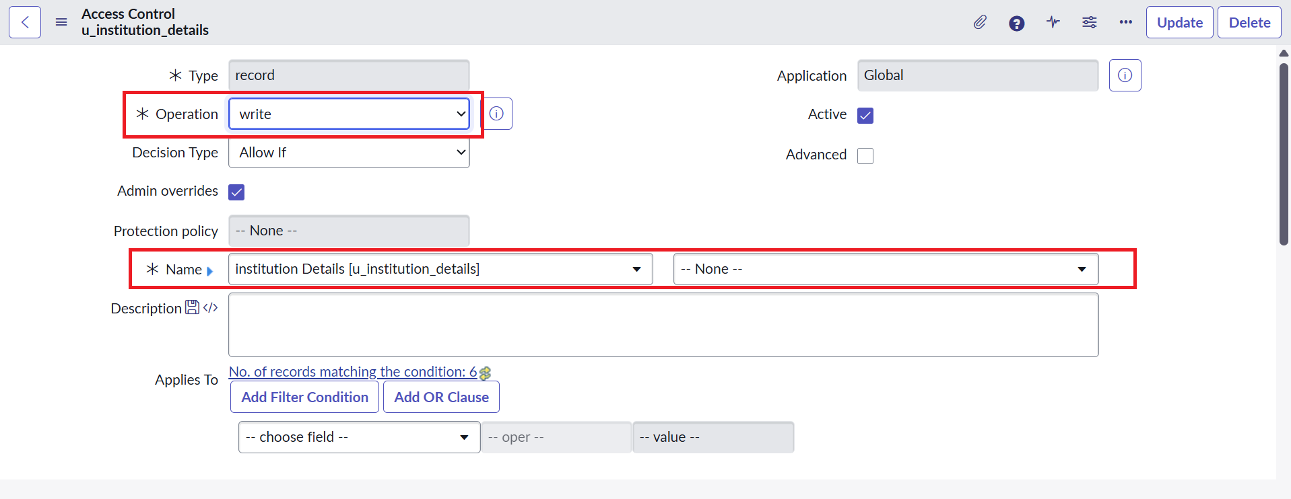
Figure: Write ACL
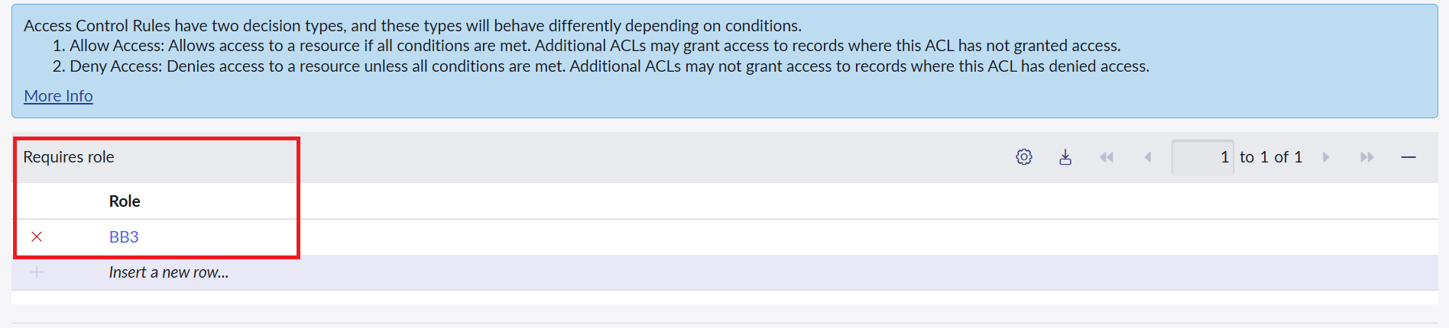
Figure: Write ACL – role bb3
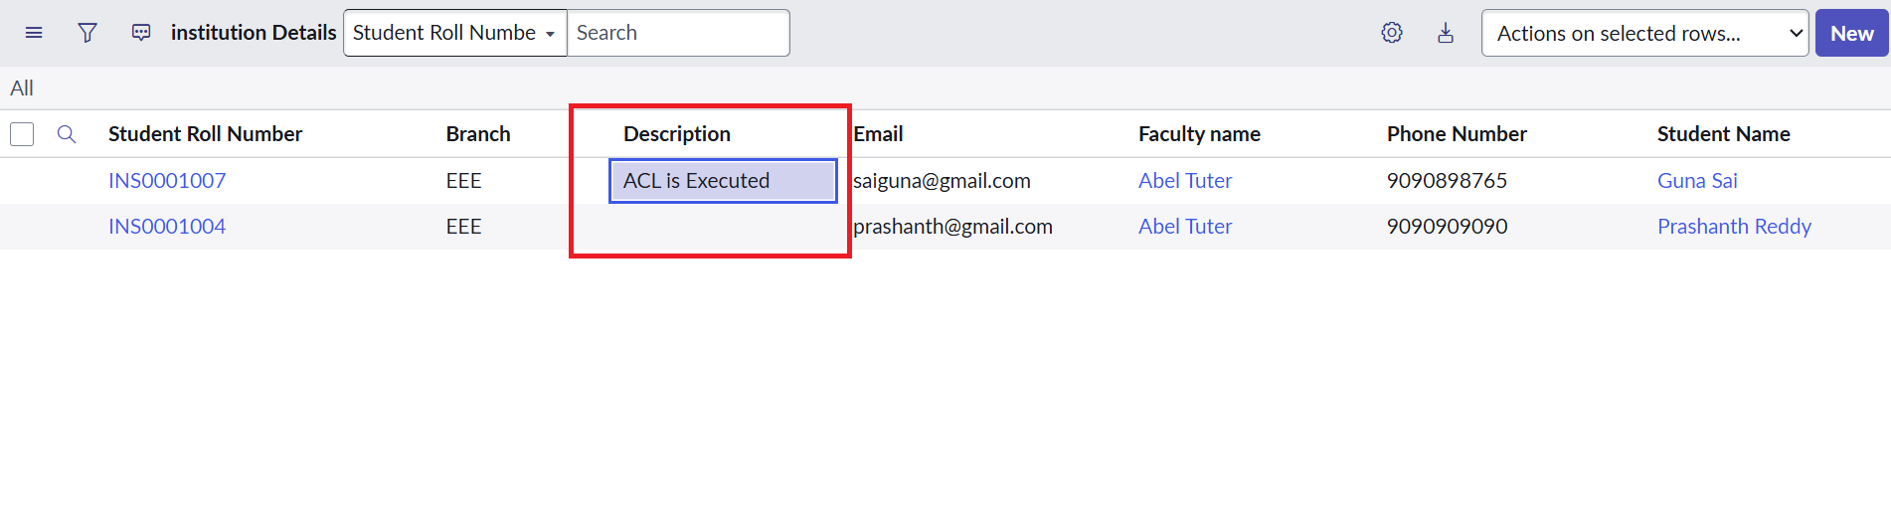
Figure: bb1–bb3: Description edited ("ACL is Executed")
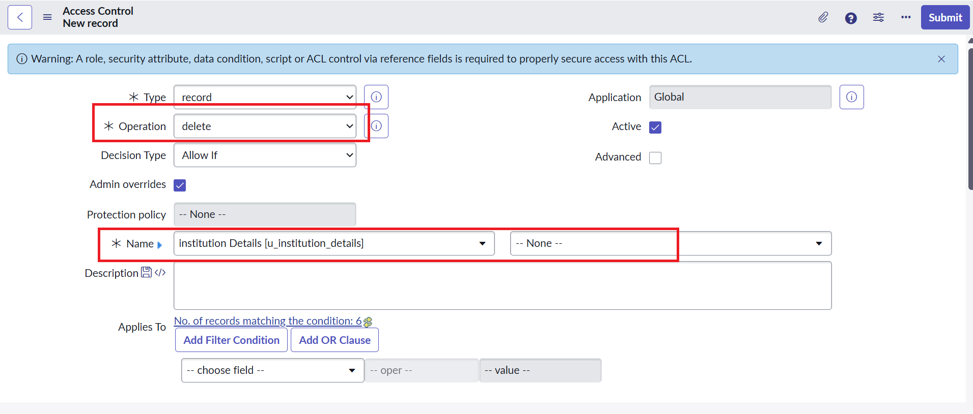
Figure: Delete ACL
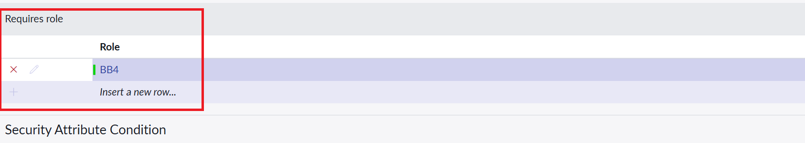
Figure: Delete ACL – role bb4
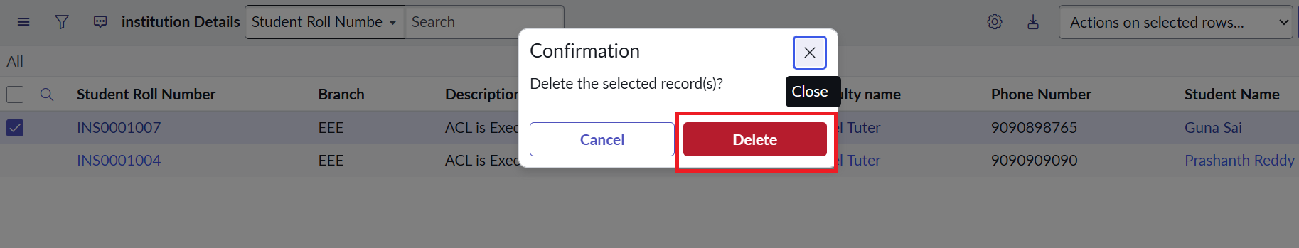
Figure: bb1–bb4: delete confirmation

8. Advantages & Disadvantages

Advantages
- Record-level security based on a field value (Branch) – not just table-level.
- Separate roles for read, create, write and delete give least-privilege access.
- Enforced by the platform everywhere (list, form, portal, APIs) – cannot be bypassed from the UI.
- Administrators keep full access; pattern is reusable for other tables and branches.

Disadvantages
- Role names are hard-coded in the script; adding branches means editing ACLs.
- Every ACL must be created and tested separately; mistakes are easy to make (e.g. wrong operation).
- ACL changes need the security_admin role and careful testing to avoid locking users out.
- Heavy scripts inside ACLs could slow list loading – scripts must stay simple.

9. Conclusion
The lab shows how script-controlled READ, WRITE, CREATE and DELETE ACLs enforce record-level security. By combining roles (bb1–bb4), the Branch field condition and a short server-side script, only authorised users can view or change EEE-branch records, unauthorised users see nothing, and administrators retain full access. All nine test cases passed.

10. Future Scope
- Replace hard-coded roles with groups or a Branch-to-role mapping table.
- Make Branch a Choice field and extend rules to ECE and CSE branches.
- Add field-level ACLs for Email and Phone Number.
- Create automated ATF (Automated Test Framework) tests for the ACLs.
- Package the ACLs in an application scope for easier deployment.

11. Appendix

Source Code (Read ACL advanced script)
(function () {
// Allow admin users full access
if (gs.hasRole('admin')) {
return true;
}
// Allow only users with role bb1 (EEE branch) – the data condition
// 'Branch is EEE' restricts WHICH records they can see
if (gs.hasRole('bb1')) {
return true;
}
// Deny access for all others
return false;
})();

Dataset (sample records – table u_institution_details)
Roll No. | Faculty | Student | Branch | Email | Phone
INS0001006 | ITIL User | Praneeth | ECE | praneeth@gmail.com | 8989090906
INS0001008 | Malla Sravan kumar | Abraham Lincoln | CSE | sravan@gmail.com | 8978908989
INS0001005 | ITIL User | Srinu Nandipalli | ECE | srinu@gmail.com | 9089909090
INS0001007 | Abel Tuter | Guna Sai | EEE | saiguna@gmail.com | 9090898765
INS0001001 | Abraham Lincoln | Yaswanth Nikku | CSE | yaswanth@gmail.com | 8989898989
INS0001004 | Abel Tuter | Prashanth Reddy | EEE | prashanth@gmail.com | 9090909090

GitHub & Project Demo Link
GitHub: https://github.com/Suhas006/Script-Controlled-ACL
Demo / project files (Google Drive): https://drive.google.com/drive/folders/1N68hjhBrpaCQtglHM7EAxkY9t21KdqrM?usp=sharing

